|  |  |
| --- | --- |
| **Name** | **MUHAMMAD MAVIA** |
| **Reg. #** | **2018-EE-427** |
| **R.Date** | 28-07-2021 |

Power System Analysis (Open Ended Lab)

QUESTION#01:

Apply Gauss Seidel method to solve the system and calculate ɸ2 and V2 after 1st iteration and match the value with simulation values?

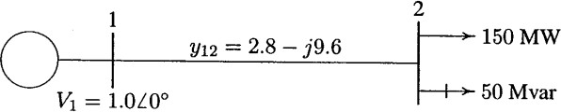

Software calculation PWS model:

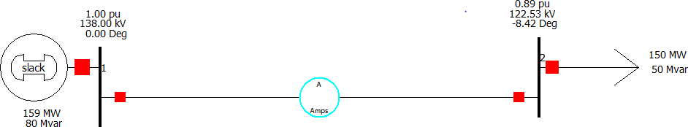

Ybus:

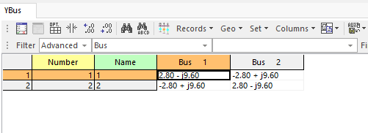

Output:

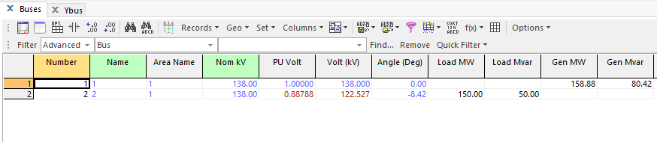

Theoretical calculation

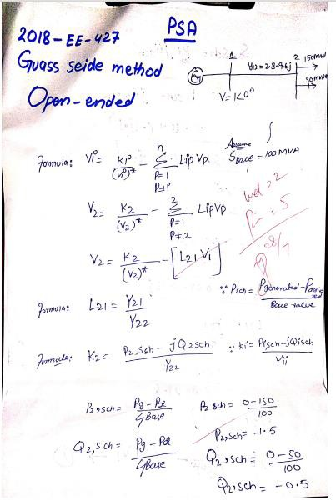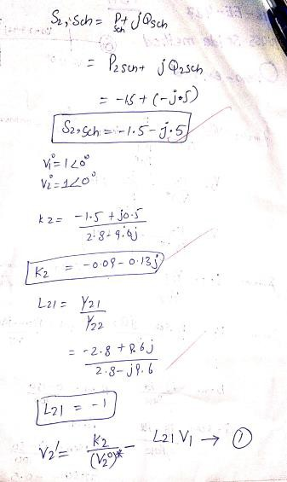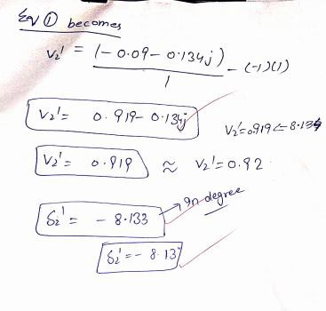

**Values Comparison:**

|  |  |  |
| --- | --- | --- |
| No. of Iteration | Experimental values | Calculated Values |
| 1st iteration of voltage  V2 | 0.92 | 0.88 |
| 1st iteration of angle $δ2$ | -8.13 | -8.42 |

**Conclusion:**

In this lab, we use fast Gauss seidel method to solve system for finding values of voltage and their corresponding angles. We observe that the values obtain by experiment and calculation are near to each other. By using this, we solve our system contain slack bus and PQ (load) bus.

`